**1. Top 10 IPOs by Issue Size**

This bar chart displays the top 10 Initial Public Offerings (IPOs) with the largest issue sizes. The length of each bar corresponds to the issue size in crores, making it easy to compare the scale of these offerings. This visualization helps in quickly identifying the most significant IPOs in the dataset.

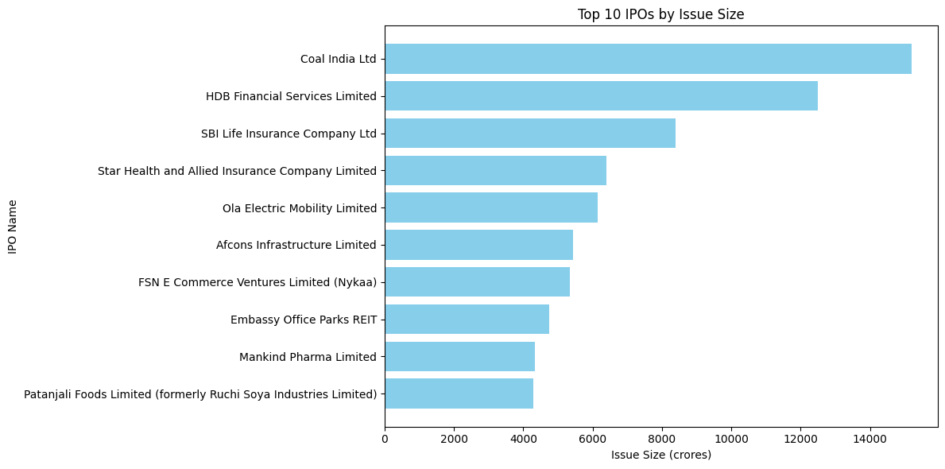

### 2. Average Listing Gain of IPOs Over the Years

This line chart illustrates the trend of the average listing gain of IPOs over a period of several years. Each point on the line represents the average percentage gain on the listing day for all IPOs in that year. This chart is useful for observing patterns and understanding whether the IPO market has been more or less favorable for investors over time in terms of immediate returns.

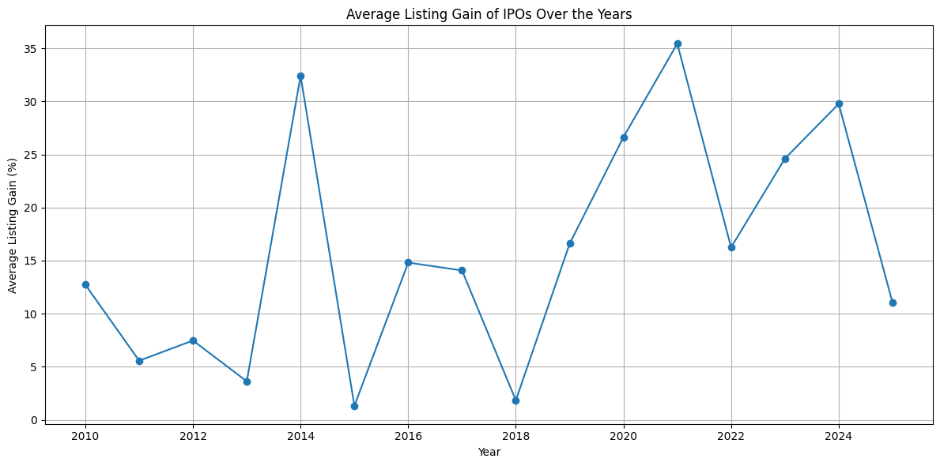

**3. Total Subscription by Investor Category**

This pie chart shows the breakdown of the total subscription money from the three main investor categories: Qualified Institutional Buyers (QIBs), High Net-worth Individuals (HNIs), and Retail Individual Investors (RIIs). Each slice of the pie represents the proportion of the total subscription amount contributed by that category. This visualization offers a clear view of which investor groups have been the most active in the IPO market.  
  
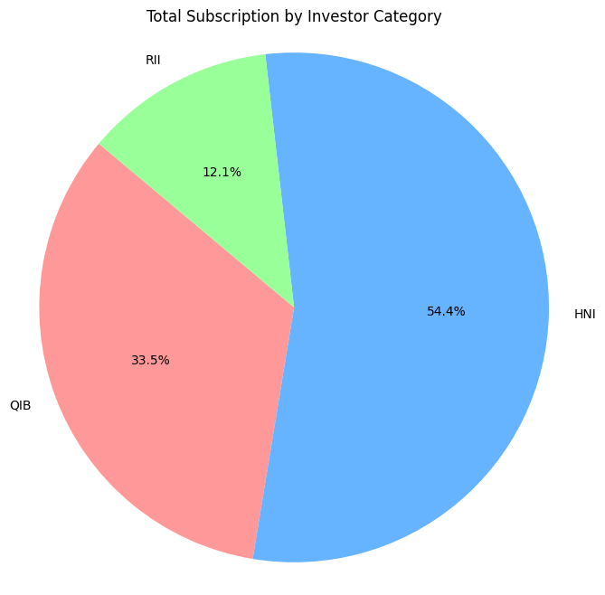

### 4. IPO Issue Size vs. Listing Gain

This scatter plot examines the relationship between the issue size of an IPO and its listing gain. Each dot on the plot represents an IPO, with its position determined by its issue size (on the x-axis) and its listing gain percentage (on the y-axis). This chart can help to identify if there is any correlation between the size of an IPO and its performance on the listing day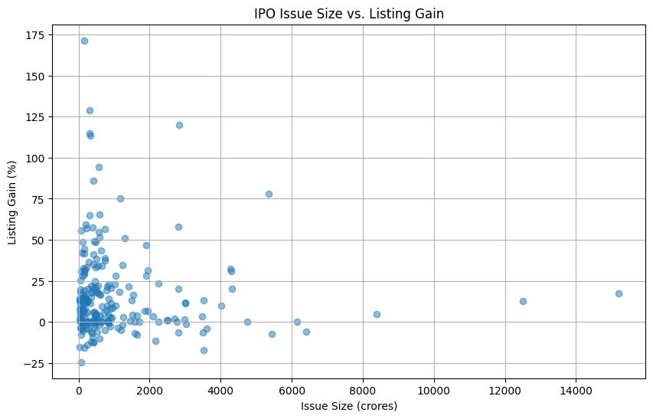

### 5. Pareto Chart of Top 20 IPO Issue Sizes

This Pareto chart displays the issue sizes of the top 20 IPOs in descending order, along with a line representing the cumulative percentage of the total issue size. The bars represent the individual issue sizes, while the line shows the cumulative contribution of these IPOs. This chart is effective in showing that a relatively small number of IPOs account for a large percentage of the total funds raised, a principle often referred to as the Pareto principle or the 80/20 rule.

